Skill 5 Lab 1
Cisco Packet Tracer Hardening Guide
Step-by-step setup for DS-07-SW1, DS-07-SW2, and DS-07-RTR1

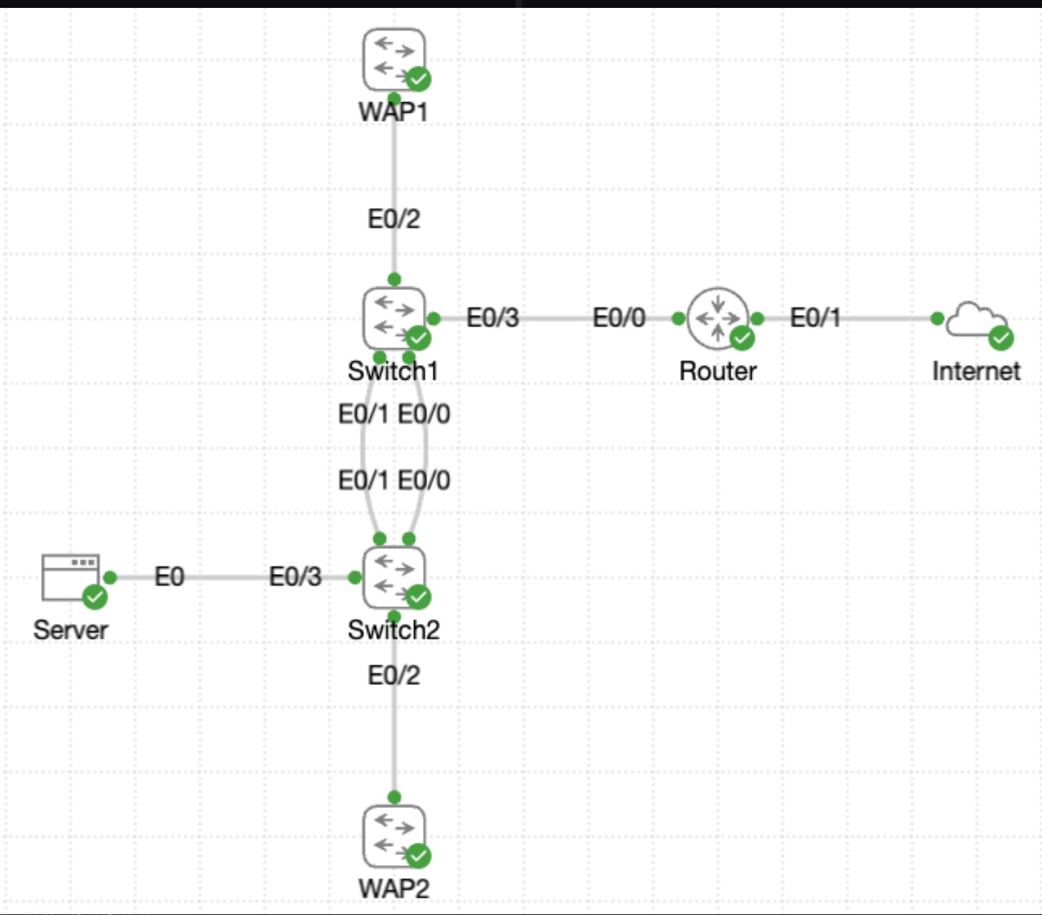
Figure 1. Lab topology used in this guide.

Lab Goal
This lab hardens two switches and one router in Cisco Packet Tracer. You will rename the devices, add banner and password protection, configure management addressing, restrict remote access to SSH, save the configuration, and verify the settings after a reboot.

Addressing and Port Map
Device | Management / Inside IP | Key Interface(s) | Purpose
DS-07-SW1 | 192.168.10.11/24 | VLAN 1; E0/3 to router; E0/0-E0/1 to SW2; E0/2 to WAP1 | Main management switch
DS-07-SW2 | 192.168.10.12/24 | VLAN 1; E0/0-E0/1 uplink to SW1; E0/2 to WAP2; E0/3 to Server | Access switch
DS-07-RTR1 | 192.168.10.1/24 | E0/0 to SW1; E0/1 to Internet | Default gateway for management network

Warning: Use SSH only on the VTY lines. Telnet must be disabled. The instructions below generate RSA keys and set a local domain name so SSH works in Packet Tracer.

Task 1. Identity and Access Hardening
Apply the following baseline settings to each device.

DS-07-SW1
enable
configure terminal
hostname DS-07-SW1
banner motd #Castle Rysen Ops: Authorized engineers only.#
enable secret CrC0ffee!
service password-encryption
ip domain-name castle.local
crypto key generate rsa modulus 1024
ip ssh version 2
end

DS-07-SW2
enable
configure terminal
hostname DS-07-SW2
banner motd #Castle Rysen Ops: Authorized engineers only.#
enable secret CrC0ffee!
service password-encryption
ip domain-name castle.local
crypto key generate rsa modulus 1024
ip ssh version 2
end

DS-07-RTR1
enable
configure terminal
hostname DS-07-RTR1
banner motd #Castle Rysen Ops: Authorized engineers only.#
enable secret CrC0ffee!
service password-encryption
ip domain-name castle.local
crypto key generate rsa modulus 1024
ip ssh version 2
end

Task 2. Console and VTY Security
Use the same console and VTY protection on all three devices.
configure terminal
line console 0
password VaultAccess
login
exit
line vty 0 15
password ShelterAccess
login
transport input ssh
exit
end
Why this matters: The console password protects local access from the first prompt. The VTY password protects remote management lines, and "transport input ssh" blocks Telnet.

Task 3. Switch Management Interfaces

Configure DS-07-SW1 management SVI
enable
configure terminal
interface vlan 1
ip address 192.168.10.11 255.255.255.0
no shutdown
description Management SVI
exit
ip default-gateway 192.168.10.1
interface e0/3
description Uplink to DS-07-RTR1 E0/0
no shutdown
exit
interface e0/0
description Trunk/Uplink to DS-07-SW2 E0/0
no shutdown
exit
interface e0/1
description Trunk/Uplink to DS-07-SW2 E0/1
no shutdown
exit
interface e0/2
description WAP1 drop
no shutdown
end

Configure DS-07-SW2 management SVI
enable
configure terminal
interface vlan 1
ip address 192.168.10.12 255.255.255.0
no shutdown
description Management SVI
exit
ip default-gateway 192.168.10.1
interface e0/0
description Uplink to DS-07-SW1 E0/0
no shutdown
exit
interface e0/1
description Uplink to DS-07-SW1 E0/1
no shutdown
exit
interface e0/2
description WAP2 drop
no shutdown
exit
interface e0/3
description Server drop
no shutdown
end
At this stage, both switches should be able to reach the router at 192.168.10.1 through VLAN 1.

Task 4. Router Management Interface
Configure the inside router interface that faces DS-07-SW1.
enable
configure terminal
interface e0/0
description Inside link to DS-07-SW1 E0/3
ip address 192.168.10.1 255.255.255.0
no shutdown
exit
interface e0/1
description Outside link to Internet
no shutdown
end
E0/0 is the management gateway for both switches. E0/1 stays connected to the Internet cloud.

Task 5. Save and Verify
Run the following checks on each device before saving, then save, and verify again.

Useful show commands
show running-config
show startup-config
show ip interface brief
show banner motd
show ip ssh

Switch-specific checks
show running-config | include hostname|enable secret|service password-encryption|ip default-gateway
show interfaces vlan 1
show interfaces description
show interface e0/2 description

Router-specific checks
show running-config | include hostname|enable secret|service password-encryption
show ip interface brief
show interfaces e0/0

Save the configuration
copy running-config startup-config
Repeat the show commands after saving. The running and startup configurations should now match.

Reload DS-07-SW1 for proof of persistence
reload
After the reboot, verify that the banner appears, the console prompts for VaultAccess, and entering enable requires CrC0ffee!.

Completion Check
- Every device prompt shows DS-07-SW1, DS-07-SW2, or DS-07-RTR1.
- The MOTD banner displays: Castle Rysen Ops: Authorized engineers only.
- show running-config lists the enable secret in hashed form (type 5 in Packet Tracer labs that use classic IOS hashing).
- VTY lines allow SSH only, not Telnet.
- DS-07-SW1 has VLAN 1 at 192.168.10.11/24 and default gateway 192.168.10.1.
- DS-07-SW2 has VLAN 1 at 192.168.10.12/24 and default gateway 192.168.10.1.
- DS-07-RTR1 E0/0 is 192.168.10.1/24 and is up/up.
- Saved configurations survive a reboot and do not return to the factory prompt.

Troubleshooting Tips
- If SSH does not work, check that the hostname and ip domain-name are set and RSA keys were generated.
- If VLAN 1 is down, make sure at least one switch port in VLAN 1 is active and not shut down.
- If a switch cannot ping 192.168.10.1, verify the router E0/0 address, cable connection, and ip default-gateway on the switch.
- If passwords appear in plain text, confirm service password-encryption is enabled.

